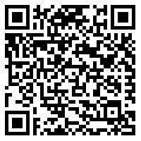

New service to help manage your   
high-profile virtual events.

Let the BT team support you with planning, set-up, and   
post-event reporting.

Learn more including how to book.

Visit the BT Support Centre. **<add link/QR code to BT Support Centre>**

